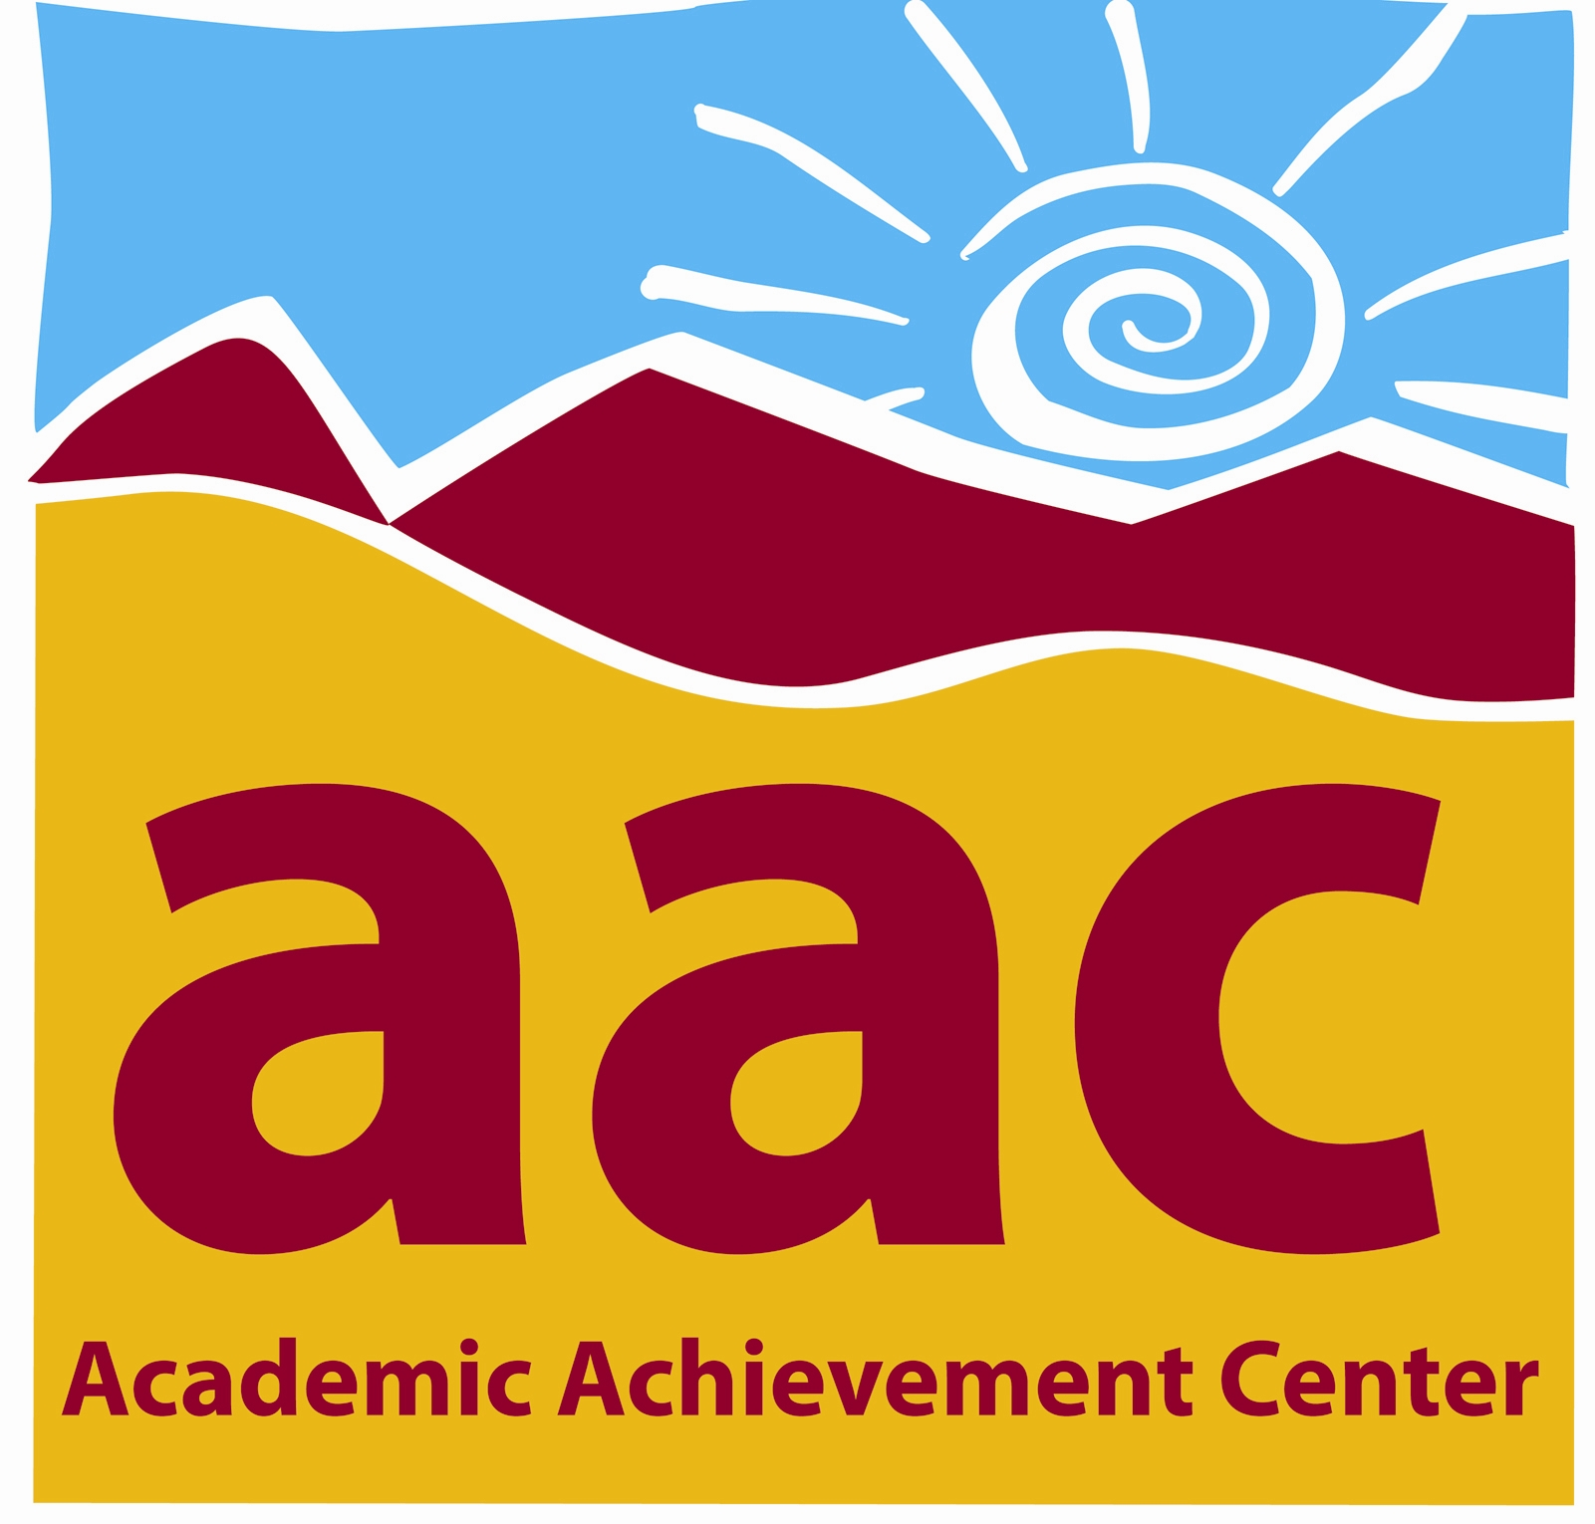
AAC Stamp Rubric

This rubric can help students recognize strengths and areas needing improvement in writing assignments. Students should use this as a tool to help evaluate work before, during, and after appointments when revising final drafts. The AAC also encourages follow-up appointments to focus on specific areas of need. Once the tutee has completed all sections of the rubric, the tutor can provide the AAC Stamp.

- Essay is typed and formatted according to assignment guidelines:
[ ] Correctly formatted
[ ] Needs corrections

- Essay is a complete draft (Introduction, Body, Conclusion):
[ ] Complete
[ ] Incomplete

- Thesis statement is clear, and is stated in the first paragraph:
[ ] Clear thesis
[ ] Unclear thesis
[ ] _____________________

- Body paragraphs support thesis well; contains evidence and citations that are used effectively:
[ ] Yes
[ ] No
[ ] Somewhat

- Essay has a solid conclusion:
[ ] Solid conclusion
[ ] Conclusion needs work
[ ] Incomplete/Nonexistent

- Overall organization and structure of essay:
[ ] Organized
[ ] Needs work
[ ] _____________________

- Sources are cited:
[ ] Yes [ ] Nonexistent
[ ] No [ ] N/A
[ ] _____________________

- Works cited page is formatted according to assignment guidelines:
[ ] Yes [ ] Nonexistent
[ ] No [ ] N/A
.

When I leave the AAC, I plan to… STAMP:

______________________________________

______________________________________

______________________________________

______________________________________

______________________________________

